

**CHATIFY**

Group 8

Names : Christian Frans Mukuan / 1920010040

Deyaninta Ekabriela Permata / 1920010050

Class : 4SC3

Faculty : Mr. Fachran Nazarullah, S. Kom

**CONTINUING EDUCATION PROGAM CENTER FOR COMPUTING AND INFORMATION TECHNOLOGY**

**FAKULTAS TEKNIK UNIVERSITAS INDONESIA**

**2021**

**PROJECT ON**Chatify

**Developed by**

1. Christian Frans Mukuan / 1920010040
2. Deyaninta Ekabriela Permata / 1920010050



**Hidro Garden**

Batch Code : 4SC3

Start Date : July, 15th 2021   
End Date : August, 01st 2021

Name of Faculty : Mr. Fachran Nazarullah, S. Kom

Names of Developer :

1. Christian Frans Mukuan / 1920010040
2. Deyaninta Ekabriela Permata / 1920010050

Date of Submission: August, 01st 2021



**CERTIFICATE**

This is to certify that a report entitled, **Chatify** is a work done by **Christian Frans Mukuan** and **Deyaninta Ekabriela Permata** of the 4SC3 class as a partial fulfillment of their course requirements at NIIT and this work is done under my direct supervision and guidance.

Coordinator:

Mr. Fachran Nazarullah, S. Kom

**ACKNOWLEDGEMENT**

Authors would like to praise to Allah SWT, Most Merciful bless and so authors can finish this Project entitled “Chatify”. Author would like to thanks to Mr. Fachran Nazarullah, S.Kom as Lecturer who has given useful suggestion which are help author in writing this paper.

The writer realized that this paper far from perfection, then the writer will be very unfettered the chest and was encouraged, if colleagues and the guide's agreeing lecturer gave the suggestion & criticism for this paper perfection.

**SYSTEM ANALYSIS**

**System Summary**:

**Background**:

Social media refers to websites and applications that are designed to allow people to share content quickly, efficiently, and in real-time. While many people access social media through smartphone apps, this communication tool started with computers, and social media can refer to any internet communication tool that allows users to broadly share content and engage with the public.

**Overview**:

Therefore, the author of this project makes a project about the website of social media, named Chatify. Chatify reshapes communication around the globe, allowing you to enjoy not only messaging but also free voice and video calls wherever you find yourself.

**ACTIVITY LIST**

|  |  |  |  |  |  |
| --- | --- | --- | --- | --- | --- |
| No | Activity Description | Date of Complete | Actual Date | Respons | Remarks |
| 1. | Create the Home Page Menu | 20 July 2021 | 20 July 2021 | Chris & Deya | Index.xml |
| 2. | Create the About Us Page Menu | 20 July 2021 | 20 July 2021 | Chris & Deya | About-us.xml |
| 3. | Create the Contact us Page Menu | 20 July 2021 | 20 July 2021 | Chris & Deya | Contact us.xml |
| 4. | Create the ChatifyToday | 21 July 2021 | 21 July 2021 | Chris & Deya | Chatifytoday.xml |
| 5 | Create the Contact Us Page Menu | 21 July 2021 | 21 July 2021 | Chris & Deya | Contact-us.xml |
| 6 | Create the Admin Regist Page Menu | 21 July 2021 | 21 July 2021 | Chris & Deya | AdminRegist.xml |
| 7 | Create the Admin Login Page Menu | 23 July 2021 | 23 July 2021 | Chris & Deya | AdminLogin.xml |
| 8 | Create the Admin Page for Catalog Menu | 23 July 2021 | 23 July 2021 | Chris & Deya | Admin.xml |
| 9 | Create Admin Page for Message Menu | 23 July 2021 | 23 July 2021 | Chris & Deya | Admin2.xml |

**IMPLEMENTATION**

- We use the App Engine on Eclipse IDE for the Website.  
- We use the Android Studio Platform for the Mobile App.  
- We use Firebase Console for Database in Populations.  
- We use Firebase Console for Authentication Gmail and Password to login.  
- We use Google Maps for visit our office.

**PREVIEW OF APPS**

**Home Page Menu**

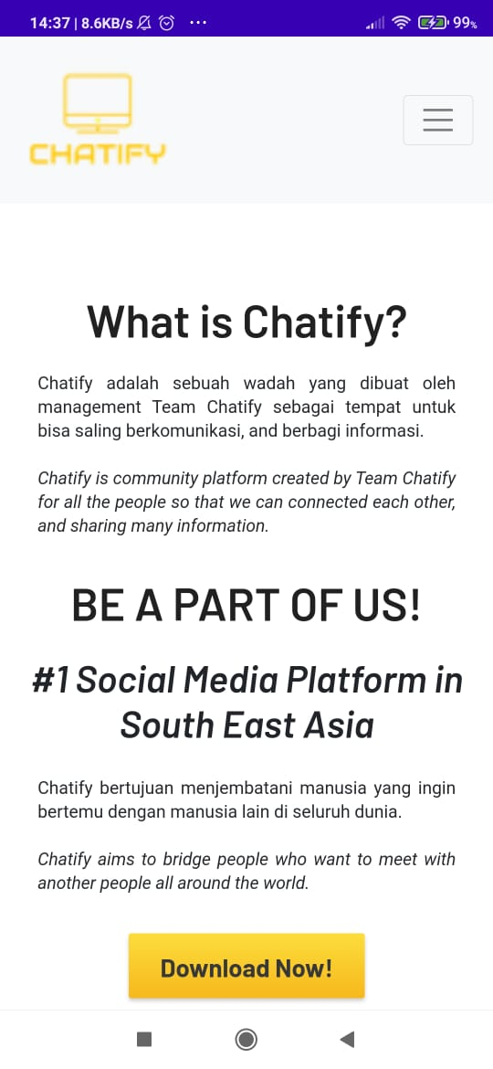

**About Us Page**

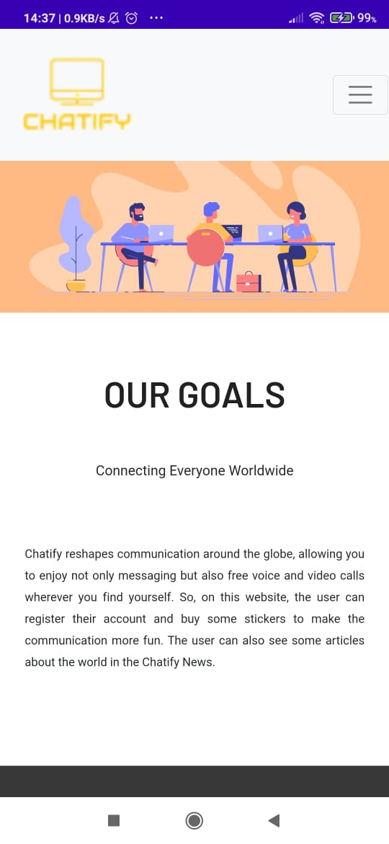

**DESIGN OF APPS**

**Chatify Today Page**

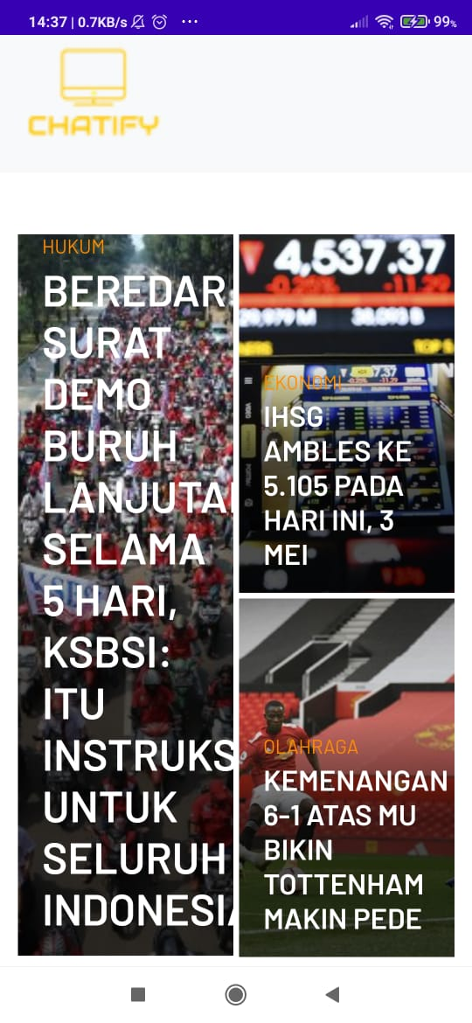

**Contact Us Page Menu**

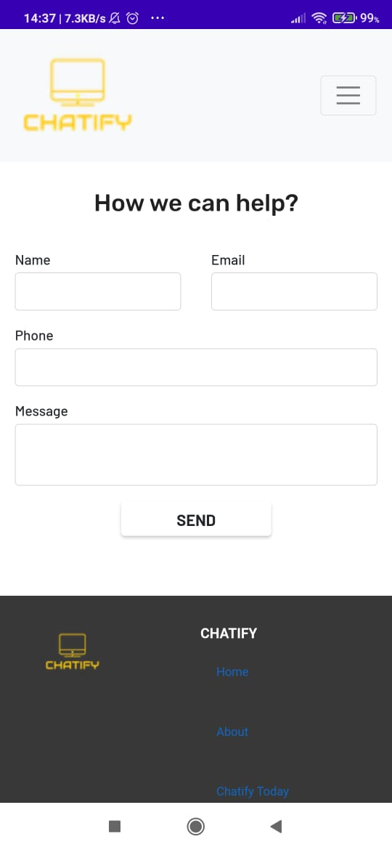

**PREVIEW OF WEB**

**Home Page Menu**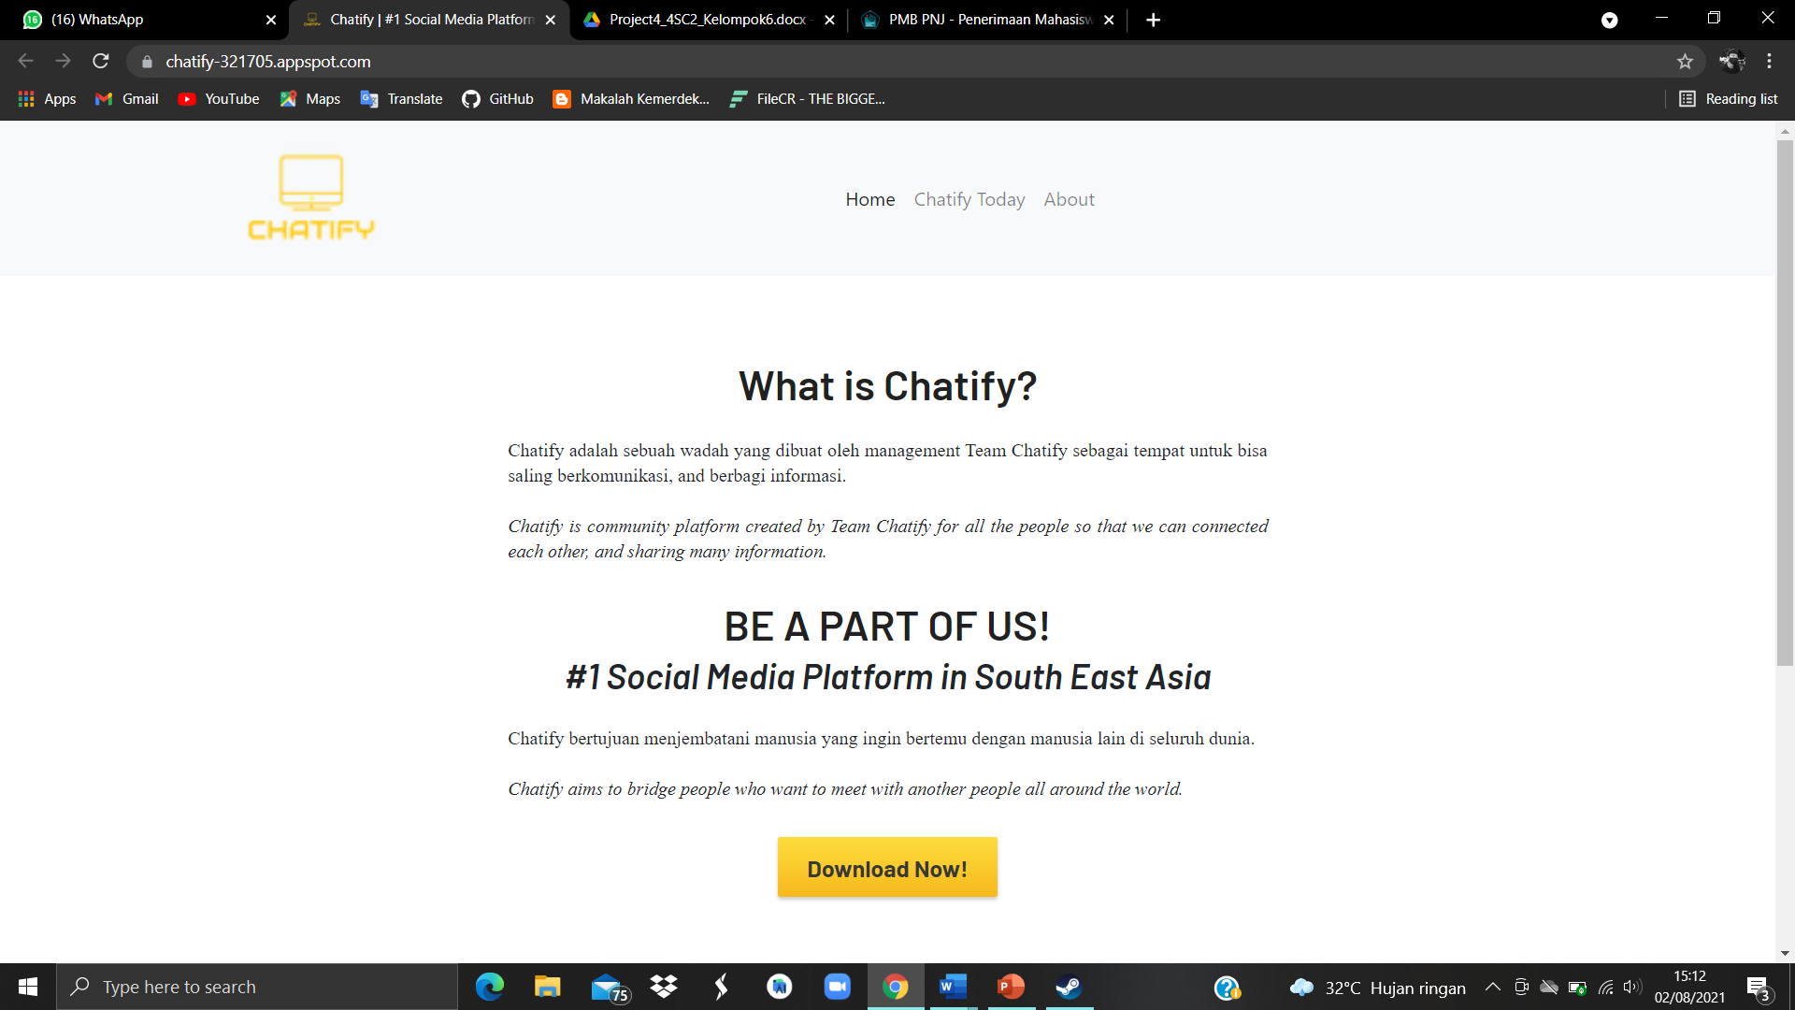

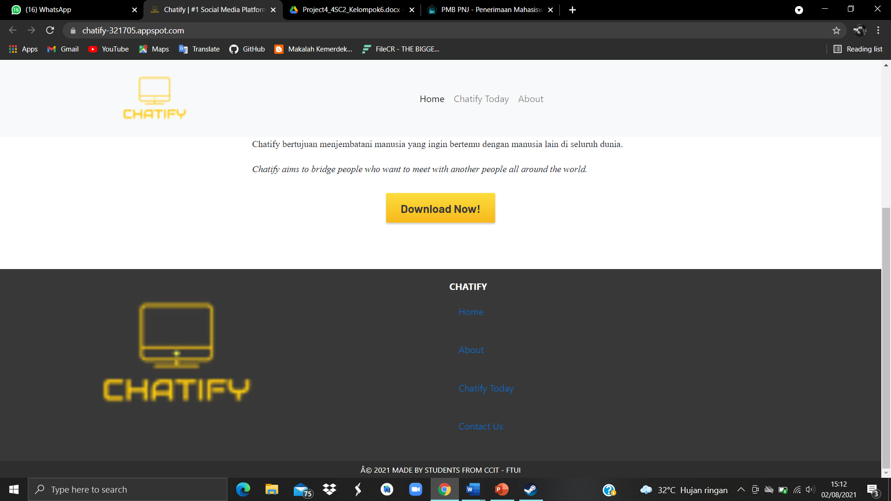

**PREVIEW OF WEB**

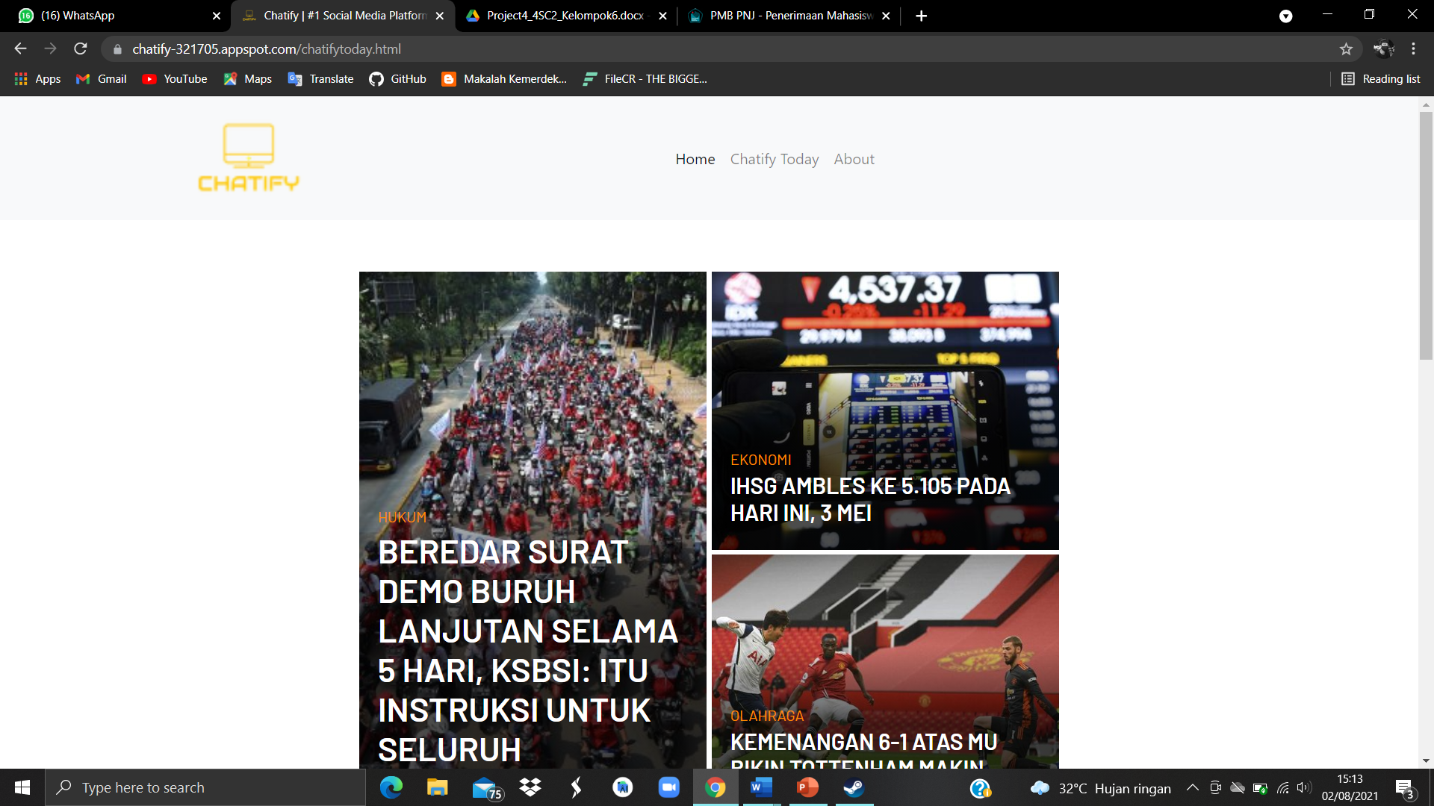

**About Us Page Menu**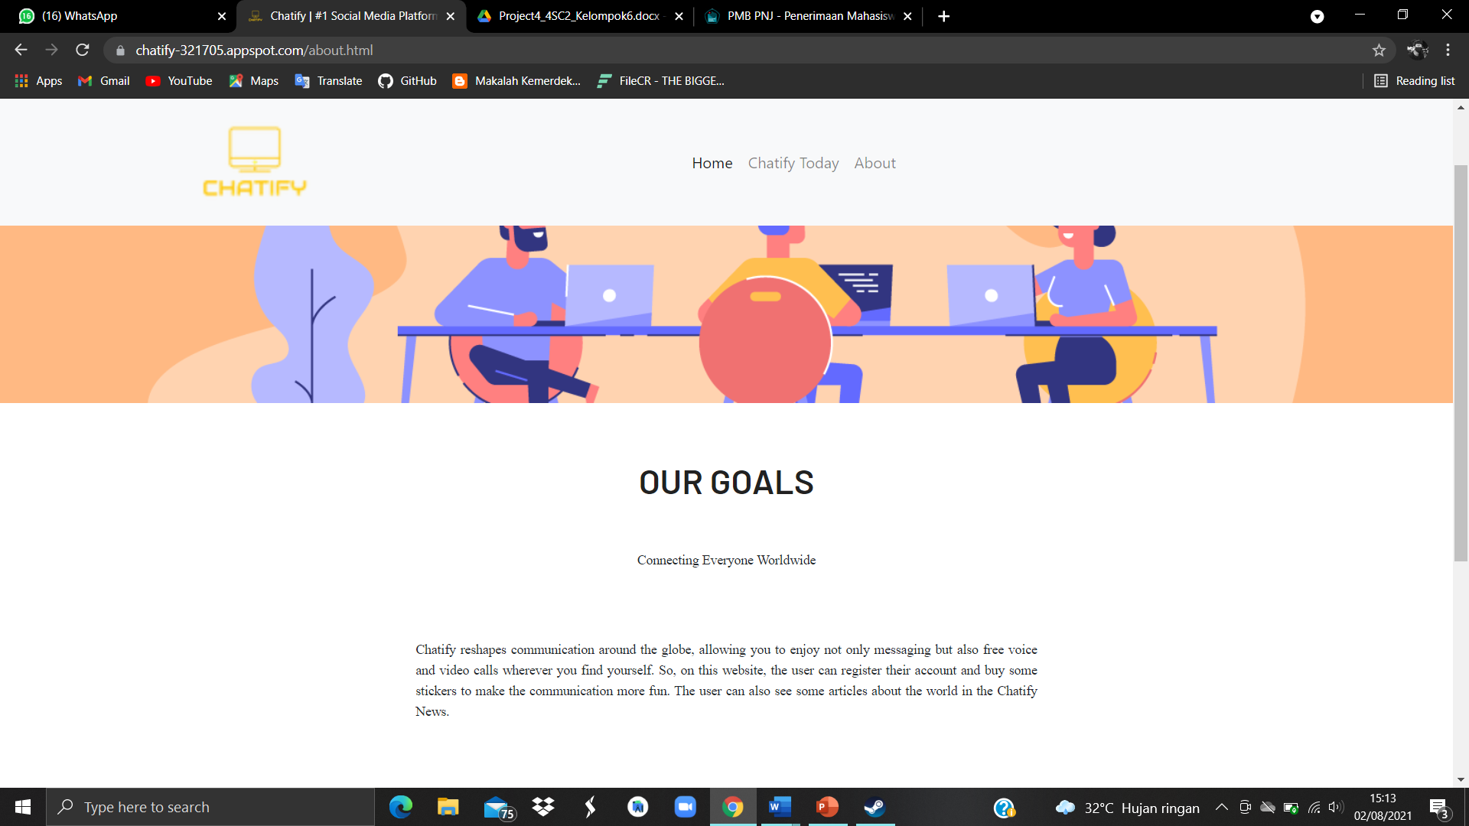

**PREVIEW OF WEB**

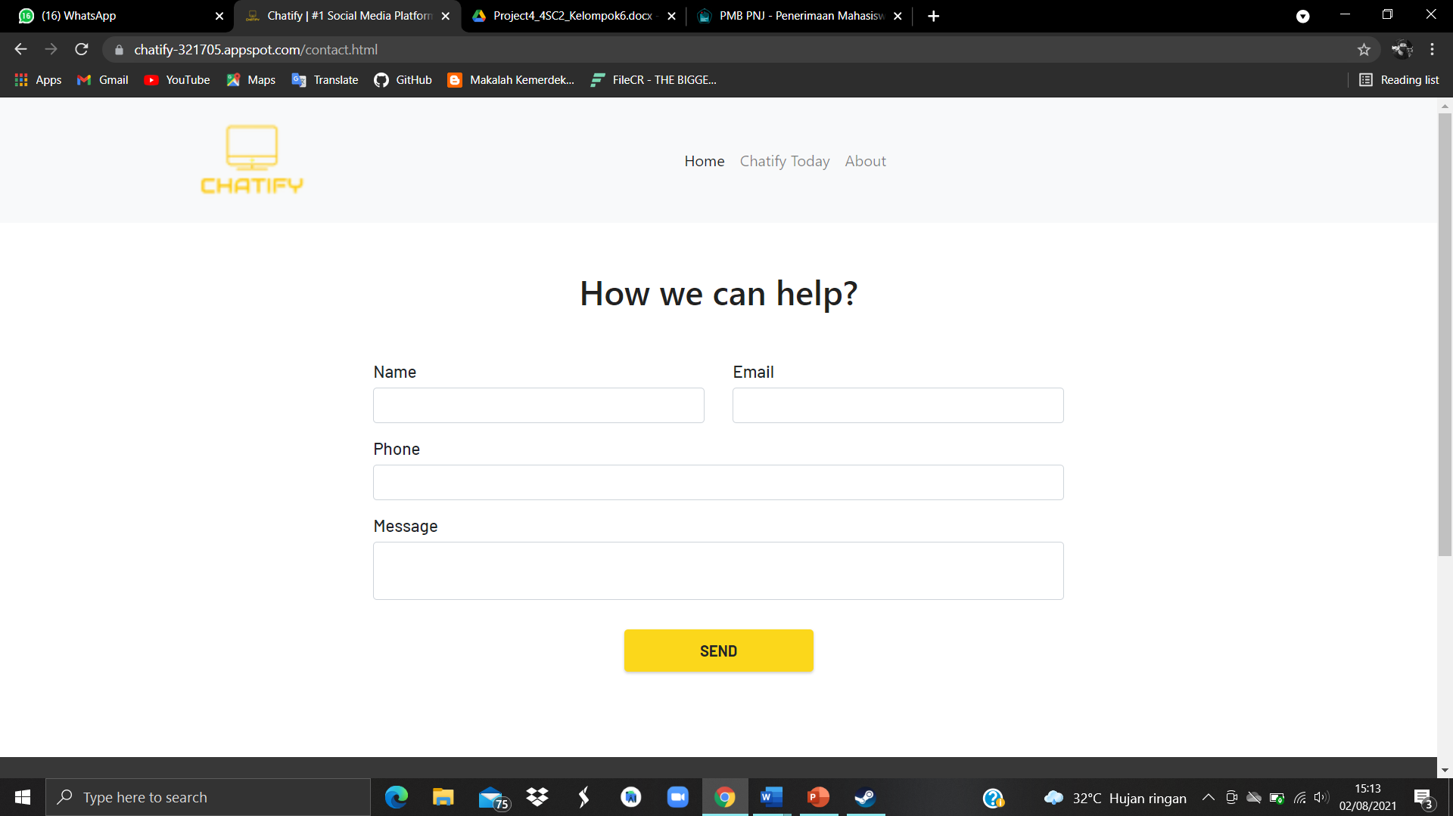

**BLACKBOX TESTING**

|  |  |  |  |  |  |
| --- | --- | --- | --- | --- | --- |
| **No** | **Scenario** | **Test Data** | **Expected Result** | **Actual Result** | **Output Result (PASS/FAIL)** |
| 1 | Admin Login | Valid | Login success and admin redirected to admin page | Login success and admin redirected to admin page | PASS |
| 2 | Admin Login | Invalid | Prompt Login failed and admin stay in login form | Prompt Login failed and admin stay in login form | PASS |
| 3 | User Add New Data | Valid | Add success and data will store to firebase and will show in admin page | Add success and data will store to firebase and will show in admin page | PASS |
| 4 | User Add New Data | Invalid | Add failed and data does not store to firebase and can’t show in admin page | Add failed and data does not store to firebase and can’t show in admin page | PASS |
| 5 | Admin Update Data | Valid | Update success and data will update in firebase and will show in catalog page | Update success and data will update in firebase and will show in catalog page | PASS |
| 6 | Admin Update Data | Invalid | Update failed and data doesn’t change in firebase and in catalog page | Update failed and data doesn’t change in firebase and in catalog page | PASS |

**BLACKBOX TESTING**

|  |  |  |  |  |  |
| --- | --- | --- | --- | --- | --- |
| **No** | **Scenario** | **Test  Data** | **Expected Result** | **Actual Result** | **Output Result (PASS/FAIL)** |
| 7 | Admin Deleted Data | Valid | Delete success and data will deleted in firebase and the catalog page | Delete success and data will deleted in firebase and the catalog page | PASS |
| 8 | Admin Deleted Data | Invalid | Delete failed and data still in the firebase and the catalog page | Delete failed and data still in the firebase and the catalog page | PASS |
| 9 | Admin Logout | Valid | Logout success and admin redirected to admin login page | Logout success and admin redirected to admin login page | PASS |
| 10 | Admin Logout | Invalid | Prompt Logout failed and admin stay in admin page | Prompt Logout failed and admin stay in admin page | PASS |

**CONFIGURATION**

**Hardware : Laptop compatible with an Intel Core – i5 processor, 4 GB RAM and 128 GB of SSD**

**Operating System : Windows 10**

**Software :**  **Eclipse IDE, Android Studio 4.0 , VSCode, Figma.**

|  |  |  |
| --- | --- | --- |
| **PROJECT FILE DETAILS** | | |
| **S.No** | **File Name** | **Remarks** |
| 1. | Chatify.rar | Contains the project for website. |
| 2. | Chatify.rar | Contains the project for Android. |

\

sssssssssss